Solution:

**One-way ANOVA: Noise Level versus Circuit type**

**Method**

|  |  |
| --- | --- |
| Null hypothesis | All means are equal |
| Alternative hypothesis | Not all means are equal |
| Significance level | α = 0.05 |

*Equal variances were assumed for the analysis.*

**Factor Information**

|  |  |  |
| --- | --- | --- |
| **Factor** | **Levels** | **Values** |
| Circuit type | 4 | A, B, C, D |

**Analysis of Variance**

|  |  |  |  |  |  |
| --- | --- | --- | --- | --- | --- |
| **Source** | **DF** | **Adj SS** | **Adj MS** | **F-Value** | **P-Value** |
| Circuit type | 3 | 12102 | 4033.9 | 22.18 | 0.000 |
| Error | 16 | 2910 | 181.9 |  |  |
| Total | 19 | 15012 |  |  |  |

**Model Summary**

|  |  |  |  |
| --- | --- | --- | --- |
| **S** | **R-sq** | **R-sq(adj)** | **R-sq(pred)** |
| 13.4870 | 80.61% | 76.98% | 69.71% |

**Means**

|  |  |  |  |  |
| --- | --- | --- | --- | --- |
| **Circuit type** | **N** | **Mean** | **StDev** | **95% CI** |
| A | 5 | 19.20 | 7.79 | (6.41, 31.99) |
| B | 5 | 70.00 | 11.02 | (57.21, 82.79) |
| C | 5 | 36.20 | 11.17 | (23.41, 48.99) |
| D | 5 | 79.80 | 20.51 | (67.01, 92.59) |

*Pooled StDev = 13.4870*

**Tukey Pairwise Comparisons**

**Grouping Information Using the Tukey Method and 95% Confidence**

|  |  |  |  |  |
| --- | --- | --- | --- | --- |
| **Circuit type** | **N** | **Mean** | **Grouping** | |
| D | 5 | 79.80 | A |  |
| B | 5 | 70.00 | A |  |
| C | 5 | 36.20 |  | B |
| A | 5 | 19.20 |  | B |

*Means that do not share a letter are significantly different.*

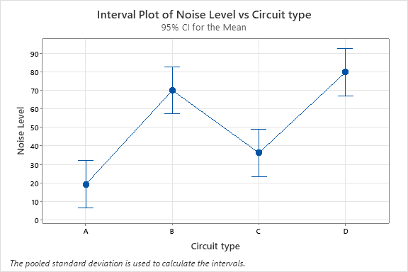

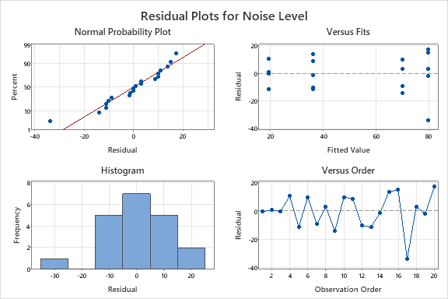

Conclusion:

1. In ANOVA the p-value=0.000<α=0.05, we reject the null hypothesis that noise is same for all types of digital circuit.
2. The lowest average noise level of circuit type A(19.20) and the highest average noise level is of circuit type D(79.80).
3. Tukey’s procedure shows that circuit type D and B shows similar performance and it is in group A. Similarly, circuit type A and C shows similar performance and they are put into group B. Hence, there are two clusters identified, first cluster (A and C) showing low average noise level and second cluster (B and D) showing high average noise level.
4. Error distribution is skewed and having some extreme observations.
5. Assumption of equal variation is not met.
6. Errors are not related to each other as shown by the graph of error vs observation order.